**The Management of Scientific and Technological Infrastructures: the case of the Mexican National Laboratories**

Leonardo Munguía

Consejo Nacional de Ciencia y Tecnología, CRIP, DRPD, México.

ORCID: 0000-0002-1947-2257

[leonardoo.munguia@ciencias.unam.mx](mailto:leonardoo.munguia@ciencias.unam.mx)

Eduardo Robles-Belmont

Universidad Nacional Autónoma de México, IIMAS, DMMSS, México

ORCID: 0000-0003-3147-3700

[eduardo.robles@iimas.unam.mx](mailto:roblesbelmont@yahoo.fr)

Juan Carlos Escalante

Universidad Nacional Autónoma de México, IIMAS, DMMSS, México

ORCID: 0000-0002-6486-5666

[jcel@unam.mx](mailto:jcel@unam.mx)

*Keywords: Scientific and technological infrastructure, National Laboratories, management, evaluation, effectiveness*

**Abstract**

The effectiveness of research units is assessed on the basis of their performance in relation to scientific, technological and innovation production, the quality of their results and their contribution to the solution of scientific and social problems. This paper examines the management practices employed in some Mexican National Laboratories to identify those practices that could explain their effectiveness in meeting their objectives. The results of other research that propose common elements among laboratories with outstanding performance are used and verified directly in the field. Considering the inherent complexity of each field of knowledge and the socio-spatial characteristics in which the laboratories operate, we report which management practices are relevant for their effectiveness, how they contribute to their consolidation as fundamental scientific and technological infrastructures, and how these can be translated into indicators that support the evaluation of their performance.

**Introduction**

Mexican National Laboratories are fundamental scientific and technological infrastructures for research and technological development for the State in areas of priority. Their distinctive characteristics are that they are financed by the government, have highly specialized research equipment, and provide quality services to the academic, governmental, social, and industrial sectors. They were established in 2006 as a result of a call published by the National Council of Science and Technology (Conacyt) with the objective of establishing and consolidating National Laboratories. The call is generally published annually, and the Council currently supports 90 laboratories.

The incipient development of the laboratories has not allowed us to evaluate their performance. Likewise, specific actions followed by management within the Mexican National Laboratories are not sufficiently known, thus wasting valuable experience that could be used to establish general management guidelines and indicators to evaluate and improve their effectiveness.

In this paper we review the management practices of the laboratories in order to answer the question of which management practices are used in the Mexican National Laboratories to ensure the performance of their activities and the fulfillment of their objectives.

For the study of these practices, we used the framework proposed by Jimenez et al. (2018) which identifies four elements that would explain the effectiveness of the National Laboratories (*Laboratory Experience, Network, Work Team Expertise* and *Leadership*). Questionnaires and interviews were given directly to some members of 10 Mexican National Laboratories and the information collected was examined with Confirmatory Factor Analysis (CFA), Multiple Correspondence Analysis (MCA) and Social Network Analysis (SNA).

We found the following: the *Experience of the laboratories*, although explained by the length of time of operation and the capacity they have to obtain equipment and develop cutting edge high quality scientific and technological production, is justified by the infrastructure, institutional support and capacity to manage financed projects; the *Network* of the laboratories shows that their relationships with other actors are explained by their thematic nature, which allows them more and better links. In the *expertise of the work team*, although the individual and collective achievements of the laboratory members are identified as central elements, there is also a condition that transcends these: the link established between the laboratory equipment and the development of the personnel themselves. Finally, the *Leadership* practices are recognized as fundamental, although in the field there is no characteristic type of leadership but rather a combination of ways to lead people.

The structure of this paper is as follows: section 1 characterizes the Mexican National Laboratories and their situation up to 2019; section 2 presents the analytical framework for the study of the practices associated with their effectiveness and presents the laboratories studied; section 3 discusses the methodologies and techniques for analyzing the information, the collection of such information, its processing and the results; section 4 discusses the results, indicates their scope and limitations and proposes some general elements to be considered in the management of laboratories that could be significantly important when developing indicators to evaluate their effectiveness; and finally, we present the conclusions reached by this exploratory exercise.

# 1. Mexican National Laboratories as Scientific and Technological Infrastructures

National Laboratories in Mexico are public scientific and technological infrastructures that integrate human, material, financial, technological, and scientific resources from universities, research centers and other higher education and research institutions, created to focus efforts on developing and carrying out strategic research on topics defined in the government's agenda such as Environment, Knowledge of the Universe, Sustainable Development, Technological Development, Energy, Health and Society (Conacyt, 2013).

Currently, there are 90 National Laboratories in operation which are managed by prestigious working groups at universities, research centers and institutes at the federal and state levels in all thematic areas, predominantly in those referring to technological development, health, and knowledge of the universe as shown in Table 1.

Table 1. National Laboratories by research topic.

|  |  |
| --- | --- |
| **Research topic** | **Number of National Laboratories** |
| Technological development | 37 |
| Health | 15 |
| Knowledge of the universe | 14 |
| Environment | 9 |
| Sustainable development | 6 |
| Energy | 6 |
| Society | 3 |
| **All** | **90** |

Source: Our own elaboration based on the National Laboratories Register (Conacyt, 2020).

In addition to these specific thematic centers, laboratory sites are concentrated in the Centro-Bajío corridor center-west of Mexico City, as shown in Figure 1 below, while some have facilities in more than one state; Michoacán, Estado de México, Morelos, Puebla, Ciudad de México, Querétaro, Guanajuato, San Luis Potosí and Nuevo León; that is: in 9 states, you will find 82.22% of the sites. The rest are distributed among 12 other states and there are 11 states with no sites. The institutions with the most laboratories are the Universidad Nacional Autónoma de México (UNAM), the Centro de Investigación y de Estudios Avanzados del Instituto Politécnico Nacional (Cinvestav), the Instituto Politécnico Nacional (IPN), the Instituto Potosino de Investigación Científica y Tecnológica (IPICYT), and the Universidad Autónoma de Nuevo León (UANL), which concentrate 53 of the 90 laboratories; that is, 58.8% of the total (Conacyt, 2020); the UNAM itself has 33.

Figure 1. Distribution of the National Laboratories home offices throughout the country. 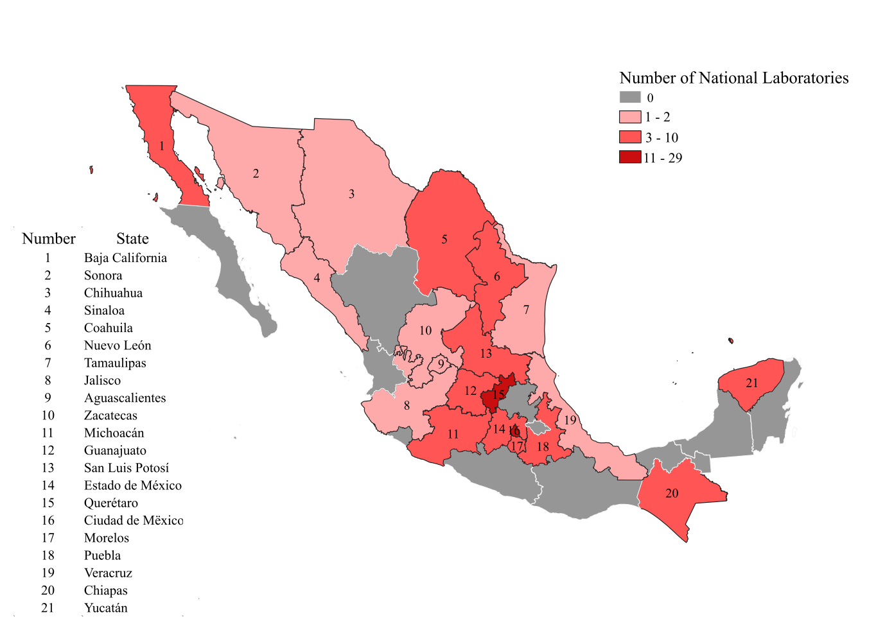Source: Our own elaboration based on the National Laboratories Register (Conacyt, 2020).

The 90 laboratories are totally or partially financed by the Mexican government through Conacyt which since 2006 generally publishes an annual call for complementary economic support for the acquisition and maintenance of specialized equipment and adaptations of physical spaces, with the specific objective of creating new and consolidating existing National Laboratories, which are conceived as "specialized units to reinforce infrastructure and equipment for scientific development and innovation in fundamental areas, in order to optimize resources, generate synergies and offer constant and quality services" (Conacyt, 2020).

In order to receive funding from Conacyt, National Laboratories are required to fulfill the following four substantive functions: research, training for human resources, service provision, and linkage. These activities increase the social benefits of investment in research and development, expand the scientific and technological capabilities of national Science, Technology and Innovation (STI) institutions in all areas of knowledge, and offer an opportunity for laboratories to develop within a framework of economic, social and environmental sustainability.

**1.1 The problem of financing scientific and technological infrastructures**

After 15 years of governmental support, today the laboratories are at different stages of development. All of them conduct or support research, human resources training, service provision, and serve as strategic platforms for innovation in the academic, industrial, social, and governmental sectors at national and international levels.

However, laboratories require continuous financial resources for carrying out their research and scientific and technological development projects, resources which are generally used to acquire new equipment, ensure their operation, maintenance, and updating.

Mexican National Laboratories rely mainly on public funds from Conacyt to cover their demand for financial resources. Only a small proportion of their funding needs come from allocations from the universities, research centers and institutes where they are located.

This situation of generalized dependence of the institutions, and specifically of the laboratories, on government spending in the current context of investment in the Mexican sector, which is characterized by a persistent and historical scarcity of economic resources, compromises the development of the National Laboratories since it affects the availability of the funding they need.

The relationship between the availability of financial resources and the effectiveness of research laboratories is mediated by the performance of the working group that, on a daily basis, "uses many consumables (diverse products and reagents, glassware, animal or plant material, office material, computer programs, etc.), some minor instruments (freezers, centrifuges, benchtop microscopes, computers, etc.) and, finally, medium-weight instrumentation purchased by one or more laboratories" (Louvel, 2007) to carry out scientific work and which must be in optimal conditions in order to successfully fulfill the laboratories’ objectives. In this sense, identifying the management practices of the National Laboratories would support the definition of good practices within the laboratories that serve to increase their effectiveness in the fulfillment of their scientific and technological objectives and, eventually, decrease their dependence on the governmental budget.

For these reasons, this project is interested in discovering the management actions taken by working groups at Mexican National Laboratories. To this end, we will try to answer the question of which management practices are used in Mexican National Laboratories to ensure the performance of their activities and the fulfillment of their objectives.

This paper employs the framework proposed by Jiménez et al. (2018) to explain the "success" of laboratories, i.e., their effectiveness in carrying out their activities and meeting their objectives. To this end we will review the actions associated with this success in 10 of the laboratories. The framework and the methodological strategy followed for its operation are shown below.

# 2. Reference framework and empirical strategy

It is recognized that each National Laboratory, as a research unit, has its own scientific and technological culture (Minhot and Torrano, 2009). This dissimilarity makes it difficult to identify operational schemes that prove to be effective for all. However, despite their differences, as scientific and technological infrastructures they respond to local-global pressures (Prahalad and Doz, 1987) and face common challenges such as their strengthening and moving into the future with self-sufficiency.

In order to understand how the working groups articulate their actions in response to the demands of their environment in the long-term, we study the practices developed in the laboratories that are associated with their effectiveness in meeting their objectives. In this sense, the reference framework proposed by Jiménez et. al (2018) is useful, as it is focused on the work of National Laboratories in general, and specifically to Mexican laboratories. The authors indicate that they have identified 4 elements common to successful laboratories, namely:

1. *Laboratory experience*. Laboratories with extensive experience are more likely to be successful in their new role as National Laboratories.

2. *Network*. Laboratories with extensive networks have an advantage in reinforcing already established connections as opposed to laboratories that start from scratch in building a strong network.

3. *Team* *expertise*. Those laboratories formed with expert teams conduct innovative research.

4. *Leadership*. The leader must be an internationally recognized scientist and must not only have the acceptance of the group, but also the will to work in collaboration with others.

The *laboratory experience* refers to the capacity of laboratories to produce scientific facts which involve having certain material and conditions that are the result of a "series of institutional modifications aimed at the material, social and symbolic conformation of a space of scientific production concretized in laboratories" (Arellano and Ortega, 2002). The working groups that have set up laboratories in universities, research centers and institutes should have institutional support and commitment, as well as the capacity to obtain the material and economic resources to equip, maintain and operate the laboratories on an ongoing basis, usually via funded research projects.

Laboratories form networks of actors that depend on the principle of preferential attachment. "Preferential attachment” is a rule that states that an entity becomes richer with the growth of its network. A node with many existing connections is more likely to gain new connections" (Honner, P., 2018). In this sense, the existence of a collaborative *Network* is critical for the development of the laboratories since their effectiveness depends not only on the management and efficiency in each of its phases but also on linking with key actors during the processes of scientific and technological development. These connections contribute to increasing its recognition and competitiveness.

Laboratories are made up of *researchers, technicians, and students with expertise* who "are committed to the line of research, patterns of activity organization, and certified production of the group and the fields in which scientific activity is deployed" (Arellano and Ortega, 2002), and who share "beliefs, habits, systematized knowledge, exemplary achievements, experimental practices, oral traditions and craft skills" (Latour and Woolgar, 1986).

Empirical evidence shows that "the leader in research units has a considerable influence on the planning of research activities and on the integration between research strategies and structures. These two roles have a major influence on the climate of the organization, which in turn has a direct effect on research effectiveness" (Knorr et. al., 1979). In other words, the "leader is one of the most important influencing factors in the performance of research units because of his contribution to the integration, atmosphere, quality of the research program, and its external links" (Nagpaul, S., 1990). For this reason, laboratories require working groups and *leaders* that permit them to produce knowledge and technologies, reproduce human capital and provide quality services that allow them to obtain resources to advance towards financial, social, and environmental self-sufficiency.

According to the above, laboratories that have a priori a certain degree of development in terms of infrastructure, project management capacity, institutional support, some collaboration networks with key actors, availability of highly specialized human resources and leaderships that have proven a positive performance in relation to scientific and technological production would have greater possibilities of contributing with knowledge and technologies to solving the problems of science and those of national-state priority within a framework of economic, social, and environmental sustainability.

In order to investigate these elements, we examined the assoiated practices of 10 Mexican National Laboratories using questionnaires and holding interviews with the researchers in charge (Technical manager/leader) and their collaborators (technicians and students). These instruments were designed based on a review of the literature on the aspects that are of interest in this work, so that their results also offer validation of the theoretical construct from which the National Laboratories are being studied.

Two semi-structured interviews and two questionnaires were applied. As for the semi-structured interviews, one was carried out with the Technical manager and the other with two of his collaborators. Four questions were asked in each one, to obtain the opinion of the Technical manager and his collaborators concerning the four aforementioned elements (laboratory experience, work group, networking, and style of leadership) and thus produce a clearer picture of the laboratories’ practices, one that will show both the vision of the Technical manager and the perception of his collaborators. A total of 10 Scientists responsible and 20 collaborators were interviewed, i.e. the Technical manager (the scientist responsible) for each of the 10 laboratories studied and two of their collaborators. 30 individuals in total, took part in this exercise.

Regarding the questionnaires, one was given to the Technical manager and the other to two of his collaborators. Forty-one questions were posed and organized into four batteries; each battery related to one of the elements proposed as common to "successful" laboratories. The answers given to the questions were closed and ordered on a Likert scale from 1 to 5, so as to express the level of Agreement/Disagreement or frequency Always/Never according to the type of information. In total, a questionnaire was given to the same 10 Scientists who were interviewed and another questionnaire to the 20 collaborators already interviewed, the same 30 individuals in total.

As mentioned above, 10 laboratories administered by the National Autonomous University of Mexico (UNAM) and located in 5 different regions of Mexico were studied, namely:

1. Laboratorio Nacional de Clima Espacial (National Laboratory for Space Weather**,** LANCE). Topic: Environment.
2. Laboratorio Nacional de Innovación Ecotecnológica para la Sustentabilidad (National Laboratory for Eco-technological Innovation in Sustainability**,** LANIES). Topic: Technological development.
3. Laboratorio Nacional de Manufactura Aditiva, Digitalización 3D y Tomografía Computarizada (National Laboratory for Additive Manufacture, 3D Digitalization and Computerized Tomography,MADIT). Topic: Technological development.
4. Laboratorio Nacional de Resonancia Magnética e Imagenología (National Laboratory for Magnetic Resonance and Imaging,LANIREM). Topic: Health.
5. Laboratorio Nacional HAWC de Rayos Gamma (HAWC Gamma Rays National Laboratory). Topic: Knowledge of the Universe.
6. Laboratorio Nacional de Materiales Orales (National Laboratory for Oral Material,LANMO). Topic: Society.
7. Laboratorio Nacional de Ciencias de la Sostenibilidad (National Laboratory for Sustainability Sciences, LANCIS). Topic: Sustainable development.
8. Laboratorio Nacional de Ciencias para la Investigación y Conservación del Patrimonio Cultural (National Laboratory of Sciences for the Research and Conservation of the Cultural Heritage,LANCIC). Topic: Society.
9. Laboratorio Nacional en Salud: Diagnóstico Molecular y Efecto Ambiental en Enfermedades Crónico-Degenerativas (National Laboratory for Health: Molecular Diagnostics and Environmental Effect on Chronic-Degenerative Illnesses,LNS-FESI). Topic: Health.
10. Laboratorio Nacional de Visualización Científica Avanzada (National Laboratory for Advanced Scientific Visualization,LAVIS). Topic: Technological development.

It is worth mentioning that these laboratories have been chosen because they are close to the place where this research is carried out, since they are located within the Universidad Nacional Autónoma de México (UNAM) and in geographical areas not far from Mexico City. Care was taken in the selection of these laboratories by identifying the 33 Mexican National Laboratories that are managed at UNAM and choosing 10 of them randomly.

# 3. Information, analysis, and results

The application of the questionnaires and interviews occurred between 2018 and 2019 and in both cases field visits were made, and the two instruments mentioned were given to the working groups. The information collected with the interviews is examined with content analysis, the information obtained with the questionnaires through Social Network Analysis (SNA), Confirmatory Factor Analysis (CFA) and Multiple Correspondence Analysis (MCA).

SNA has been used to learn the structure of the network relationships that make up the collaborations of the laboratories studied, thus providing a visualization and some local and structural measures. CFA is also used. This is essentially a validation of psychometric measurement instruments and constructs, useful for this work since questionnaires are used to explore the management practices of the Mexican laboratories; Finally, MCA is used fundamentally to estimate the proximity that exists between the leadership study variables, allowing the measurement and visualization of the association between the study subjects and the attributes of leadership.

The analysis of the information of the four distinctive elements of laboratory effectiveness is presented below:

1. Laboratory Experience, according to the analysis of the interviews, confirms that those laboratories that have the capacity to manage funded research projects, institutional support and equipment prior to their insertion in the Conacyt program have greater opportunities to perform better in their new role as National Laboratories. Many of the laboratories that were awarded the distinctions already had a previous trajectory of between 3 and 10 years. They have, therefore, certain technical conditions, links, and recognition. The HAWC National Laboratory, for example, is a laboratory that already had technical and instrumental capabilities, institutional recognition, and international prestige prior to its designation as a National Laboratory.
2. Likewise, the interviews confirm that experience is also fundamental at the individual and collective levels of the laboratory members, since in the experience of the work team, the more social capital (Bourdieu, 1987) the individual members of the laboratory have, the more probability of effectiveness in the performance of their scientific work. Here it was also identified that the training of laboratory collaborators is strengthened by the availability of specialized equipment, playing an important role on the availability of a pool of highly qualified personnel.
3. The networking structures were obtained from the laboratory members’ responses to the questionnaires, which shows the actors with whom they have had a relationship in the last three years for different activities, such as research, human resources training, provision of services, etc. The list of relationships is a table of adjacency (origin, destination) and it lists the laboratories and the actors with whom there have been relationships; in total there are 221 nodes and a total of 232 links. The laboratory with the highest number is LANCIS, with 63, while the laboratory with the lowest number is LANIREM with level 7; the actor with the highest level and which is not a National Laboratory is CINVESTAV, with level 4.

As for the structural measures, the level of centrality is used. This shows the importance of the actors in the network in relation to the other actors with which it is linked. This is estimated with the measure

CD(v) = $\frac{δ(v)}{n-1}$

where $δ$ (v) is the degree of a certain node and n the total number of nodes in the network. In this exercise the nodes with the highest degree of centrality are LANCIS (0.28), LANCIC (0.19) and HAWC (0.15). All other laboratories have levels below 0.10, as shown in Figure 2.

Figure 2. Levels of centrality of the nodes of the laboratory network.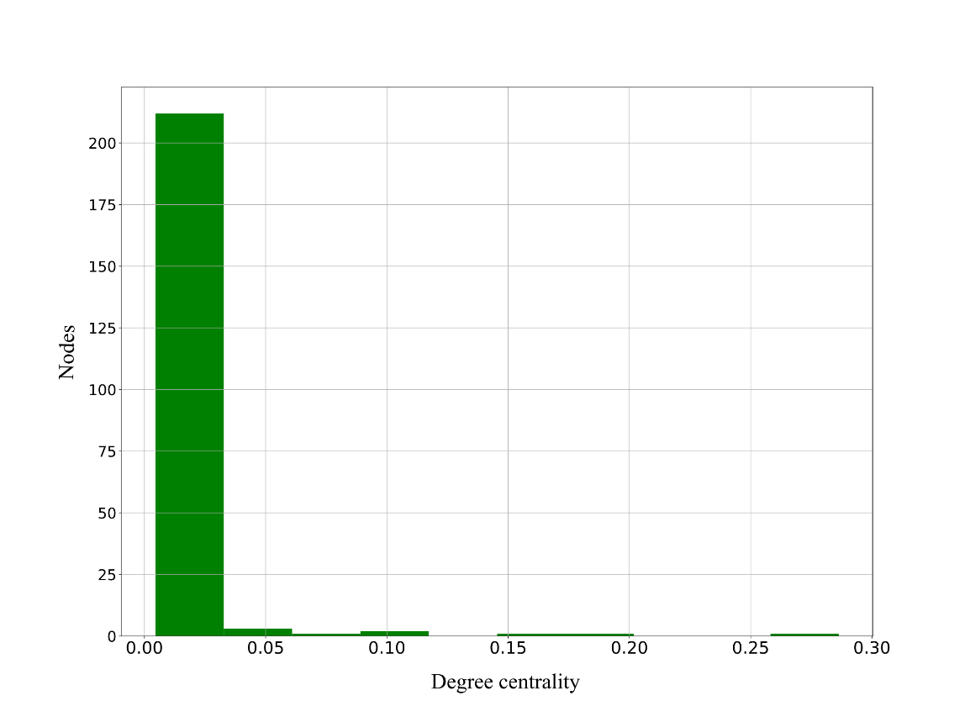

Source: Data obtained from the questionnaires given to the National Laboratories in 2018.

To visualize the level of centrality of the actors in the laboratory network, the Fruchterman-Reingold algorithm (1991) is used. This algorithm determines a fixed equilibrium distance between the nodes, so as to bring the groups of nodes that are better connected closer together, as shown in Figure 3.

In the network the collaborations of the 10 laboratories are visualized. In general, these are the laboratories that are positioned on the gradient of the degree of centrality $≥$ 0.1. The actors with whom the laboratories collaborate in sharing infrastructure, training highly specialized human resources, carrying out research work and in general providing services are colored and positioned with a gradient $≥$ 0.01 and there are more than 200 of these.

Figure 3. Collaboration network of the laboratories studied.

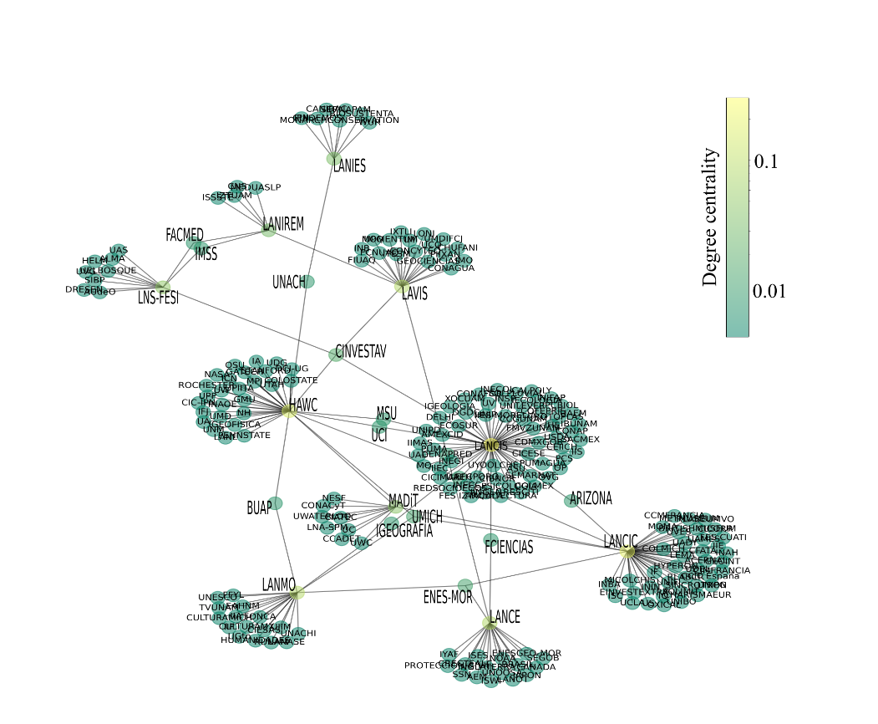

Source: Data obtained from the questionnaires given at the National Laboratories in 2018.

In general, the laboratories studied have a higher degree of centrality, followed by other research centers and universities, as is the case of CINVESTAV, UNACH and ENES-MOR, among others. It is revealed that the laboratories mainly have links with academic actors, which is natural due to the activities they systematically carry out (human resources training and research). Relations with actors of industry are less frequent, as are those with actors of government and civil society.

1. Regarding the study of Leadership, the practices with which the Scientists responsible (or leaders, who are researchers with PhDs, with prestige in their area of knowledge and recognized professional trajectory, who act as heads of the laboratory work group) influence the performance of activities concerning scientific work in accordance with the particular objectives of these scientific and technological infrastructures were investigated.

A typology for the study of leadership in research units was used for developing countries, particularly for the Mexican case, which considers authoritarian, paternalistic, technocratic, and democratic styles (Jiménez, 1990). The practices of each style were characterized and transferred to a questionnaire with 41 items with responses on a Likert scale 1-5 to assess the frequency of occurrence of practices and measures of agreement/disagreement with them.

According to Jiménez (1990):

- An authoritarian leader tells subordinates.

- A paternalistic leader sells to his children.

- A technocratic leader consults his assistants, and

- A democratic leader joins his collaborators

In this sense, the authoritarian leader is "a control figure with sufficient authority" (Pellegrini, E. and Scandura, T., 2008; Zylfijaj, K. et al., 2014), who has centralized decision-making. The authoritarian leader does not allow his followers to participate in decision making, tells his subordinates what activities must be performed for the fulfillment of the organization's goals, reduces the dedication of the followers to a single task and exercises a strict supervisory role. He is a leader who dictates to his subordinates.

Paternalistic leadership means a strong figure of authority, moral integrity, discipline and paternal benevolence. It is based primarily on unconditional obedience and loyalty. Underlying this style is a "patent inequality of power between the leader and his followers" (ibid., 2008). The leader is interested in life inside and outside the workplace and promotes the well-being of his collaborators so that they can perform effectively. He essentially provides them with support, protection, and care. He "assumes the role of a father figure and has personal emotional ties" (Negandhi, 1975) with them. The paternalistic leader does not consult on decisions, but rather explains to his followers the reason for his decisions; he is a leader who sells decisions to his children.

The technocratic leader has experience in some area of responsibility, especially when it has to do with scientific or technical knowledge. He "is an individual who has received technical or scientific training and firmly believes in the advantages of using science to solve problems" (ibidem, 1990). This leader makes decisions based on his knowledge and the use of technology. "He is open to suggestions from his subordinates, but the final decision is made by himself" (ibid., 1990), He is a leader who consults his assistants.

Finally, a democratic leadership stands out for "conducting itself by principles of self-determination, inclusion, equal participation and deliberation of its followers" (Gastil, 1994). The democratic leader "distributes responsibilities among members, empowers them and serves as a fundamental support in decision-making" (ibid., 1994). This leader does not concentrate responsibility, but distributes it and demands its fulfillment, offers instructions or suggestions, and seeks to build new leadership. This is a type of leadership where constructive participation, facilitation and maintenance of a healthy environment are promoted. He is a leader who joins his collaborators.

As mentioned, these leadership attributes were translated into items grouped in 4 classifications (leadership styles) that were labeled and then applied in two questionnaires with 41 questions, one questionnaire addressed the Technical manager and the other his collaborators. After application validation was carried out with the CFA[1] to validate the constructs of its measures. The indicators used were the Comparative Fit Index (CFI) and the Tucker Lewis Index (TLI)[2] and for reliability we used Cronbach's (Nunnualy, J., & Bernstein, I., 1994) and McDonald's Ω (1999). The variables[3] that would best explain each type of leadership were found, namely:

Table 2. Standardized factor loadsof the authoritarian style variables.

|  |  |  |
| --- | --- | --- |
| Technical manager... | | |
| Variables | Description | Loads |
| q6 | Monitors group discussions | 0.57 |
| q9 | Provides feedback after decisions have been made | 0.55 |
| q17 | Personally directs the completion of lab activities | 0.81 |
| q23 | Requires activities to be done as specified by him | 0.68 |
| q32 | Requests unquestioning obedience | 0.60 |
| α= 0.77; Ω=0.78; CFI = 1; TLI= 1 | | |

Source: Data obtained from the questionnaire applied to the National Laboratories (2019).

Table 3. Standardized factor loads of the paternalistic style variables.

|  |  |  |
| --- | --- | --- |
| Technical manager... | | |
| Variables | Description | Loads |
| q2 | Takes into account the interests of employees | 0.58 |
| q5 | Explains decisions once they have been made | 0.71 |
| q11 | Delegates functions | 0.62 |
| q16 | Provides support, protection, and care | 0.75 |
| q31 | Is interested in the well-being of the employees | 0.90 |
| α= 0.83; Ω=0.84; CFI = 0.93; TLI= 0.85 | | |

Source: Data obtained from the questionnaire applied to the National Laboratories (2019).

Table 4. Standardized factor loads of the technocratic style variables.

|  |  |  |
| --- | --- | --- |
| The Technical manager... | | |
| Variables | Description | Loads |
| q3 | Listens to feedback and incorporates it into technical decisions | 0.84 |
| q7 | Consults on technical issues | 0.79 |
| q28 | Assesses efficiency in laboratory operation | 0.94 |
| α= 0.87; Ω=0.89; CFI = 1; TLI= 1 | | |

Source: Data obtained from the questionnaire applied to the National Laboratories (2019).

Table 5. Standardized factor loads for democratic style variables.

|  |  |  |
| --- | --- | --- |
|  | The Technical manager... |  |
| Variable | Description | Loads |
| q4 | When making decisions, he calls upon the collaborators | 0.62 |
| q10 | Encourages participation and free discussion | 0.88 |
| q12 | Gives guidance when in doubt | 0.76 |
| q20 | Reminds the group of collective responsibilities | 0.66 |
| p22 | Distributes responsibility | 0.74 |
| α= 0.83; Ω=0.85; CFI = 0.88; TLI= 0.77 | | |

Source: Data obtained from the questionnaire applied to the National Laboratories (2019).

For the profiling of leadership styles, those variables with loads higher than 0.50 were taken. The score was calculated for each of the laboratories and the MCA[4] was carried out. The point cloud with the results of this analysis is shown in Figure 4. The leadership styles identified within the laboratories are not pure, since the practices observed in personnel management have characteristics of more than one type. The LANIREM, HAWC and LANCIS laboratories show practices that are closer to the technocratic and paternalistic styles, while LANCE is close to democratic leadership and MADIT corresponds to the authoritarian style. On the other hand, the styles exercised in LANMO, LANIES, LAVIS, LN-FESI and LANCIC are not defined under this metric.

Figure 4. Leadership styles exercised in the National Laboratories studied.Source: Data obtained from the applied questionnaire to the National Laboratories (2019).

# 4. Discussion

# The related practices that explain the threshold of laboratory experience that were identified exhibit the management capacity of projects financed by the Responsible Scientist and the facilities provided by the institutions to carry out these projects, mainly the acquisition, maintenance and operation of specialized equipment, in which institutional support and commitment play a central role. Decision-makers and institutions with Mexican National Laboratories could consider establishing work schemes to strengthen the management capacity of funded research projects and the critical routes to reinforce their technical-scientific capabilities.

# The experience of the work team is explained by practices that promote the expansion of the pool of knowledge and individual skills of laboratory members. This is directly related to the availability of sufficient, modern, and adequate equipment for scientific work, as well as the recruitment of new talent. Scientific equipment is thus intertwined with capacity building of staff and attraction of other members. The practices associated with this element denote the level of qualification of the members, their results in the laboratory, both individually and collectively, and their contribution to the training of new scientists and technologists, as do the links with other entities to access other scientific and technological infrastructures and exchange experiences and personnel. Therefore, we consider that the evaluation of the experience of the working team should also consider the accessibility to other teams and the existence of collaboration instruments with other institutions.

# Continuing with the Networking factor, there are notable actions aimed at exploiting relationships propitiated by conditions such as nature and subject matter. These patterns suggest some regularities regarding the thematic orientations of the laboratories and the types of entities with which they relate, as shown by the most frequently observed proximities between laboratories and academic entities. Along this line, the laboratories that have more key collaborations in services, technology transfers and scientific and technological production are indirectly linked to other actors with which establishing relationships could raise their recognition and competitiveness. Thus, the assessment for this dimension could consider specifying the type of entities with which relationships are established, their orientation, and the means and modes through which a link is developed, so that the resources involved in a collaboration can be used efficiently.

# Finally, the personal styles of leadership exercised by the Scientist in charge or leaders observed in these scientific and technological infrastructures are varied, although technocratic, democratic and paternalistic style practices are more frequent. It is considered that the framework used to analyze leadership is not sufficient to characterize the style of leading the personnel of a research unit. It is useful to individually characterize the ways in which laboratory personnel organize themselves to carry out scientific work, but observations are needed to broaden the scope of this measurement and also another conceptual framework is needed to incorporate other types of horizontal, collaborative and relational leadership.

# In short, the factors or dimensions that explain the effectiveness or success of laboratories are neither unique nor definitive, nor are the practices into which they are translated. An alternative for consistently understand the practices that promote the effectiveness of the Mexican National Laboratories could be the extension of the study to more laboratories given that this would allow us to deepen our knowledge of the managerial strategies of scientific and technological infrastructures beyond UNAM (the largest and most prestigious university in Mexico), beyond the geographical center of the country (where the economic, technological and cultural resources are concentrated), and beyond the thematic orientations seen in this paper.

# Conclusions

Mexican National Laboratories concentrate resources and efforts of the State to meet the demand for knowledge and technologies and to take advantage of strategic opportunities, while increasing the social benefits of investment in STI. After almost 15 years, since this important initiative was launched by Conacyt, it has been essential to carry out a diagnosis that allows us to learn the capacities and practices of the laboratories that have proven to be effective in the fulfillment of their activities and objectives. Their understanding and dissemination would support decision-making geared towards strengthening scientific and technological infrastructure, optimizing resources, generating synergies and offering quality services within a framework of financial, social, and environmental sustainability. In this sense, the present study responds in a fundamental way to the question of what management practices are used in National Laboratories to ensure the performance of their activities and the fulfillment of their objectives.

The answer to this question was found with the absence of information related to strategies as successful or effective practices, specifically in Mexican National Laboratories. This implied mobilizing the framework proposed by Jiménez et al. (2018) to address the issue directly through the application of questionnaires and interviews, to a sample of 10 laboratories based at UNAM. The data collected through these instruments refer to Laboratory Experience, Networking, Work Team Experience and Leadership, and were analyzed, among other means, making use of CFA, SNA and MCA.

As a result, the Laboratory Experience shows that Mexican National Laboratories have a lifespan of between 3 and 10 years, even before being designated as such, during which they have assembled specialized teams that are recognized in their regions, in the country or internationally, have developed a level of cutting-edge scientific and technological production and strategically contribute in the scientific, technological, economic, political and social fields. In terms of Networking, the laboratories most frequently exploit relationships that by their nature mean that they can take advantage of the conditions of their immediate environment, in the institutional and thematic areas. In regard to the Experience of the work team, it was found that the laboratories are distinguished by the quality of their personnel, as well as the quantity and quality of the laboratory equipment they have, allowing them to increase effectiveness in their work. Finally, Leadership in the laboratories is characterized by technocratic, democratic, and paternalistic practices in decision-making.

**References**

Arellano, A. & Ortega, C. (2002). Caracterización de la investigación biotecnológica del maíz en México: un enfoque etnográfico. *Nueva Antropología,* 18(60), 47–68.

Bollen, K. (1989). Structural Equations with Latent Variables. Toronto: John Wiley.

Bourdieu, P. (1987). Los Tres Estados del Capital Cultural. *Sociológica,* 2(5), 11-17.

Brown, T. (2006) Confirmatory Factor Analysis for Applied Research. New York: The Guilford Press.

Conacyt. (2013). Programa Especial de Ciencia, Tecnología e Innovación 2013-2018 (PECiTI).. april 29, 2019, Sistema Integrado de Información sobre Investigación Científica y Tecnológica website: <http://www.siicyt.gob.mx/index.php/normatividad/nacional/programa-especial-de-ciencia-tecnologia-e-innovacion-peciti>

Conacyt. (2020). Laboratorios Nacionales Conacyt. october 17, 2020, Consejo Nacional de Ciencia y Tecnología website: <https://www.conacyt.gob.mx/index.php/el-conacyt/desarrollo-cientifico/programa-de-laboratorios-nacionales>

Fruchterman, T & Reingold, E. (1991). Graph drawing by force-directed placement. Software: Practice and Experience, 21(11), 1129-1164.

Gastil, J. (1994). A definition and ilustration of democratic leadership. *Human relations*, 47(8), 953–975.

Greenacre, M. (1993). Correspondance analysis in practice. Boca Raton: Chapman & Hall/CRC.

Honner, B. (s. f.). How Network Math Can Help You Make Friends. August 29, 2018 website: <https://www.quantamagazine.org/how-network-math-can-help-youmake-friends-20180820/>

Jiménez, J. (1990). Leadership styles in Mexican research units: a frame setting. In Organization and sociology of research (p. 82–87). New Delhi: Wiley Eastern.

Jiménez, J., Escalante, J.C., Vargas, D., Ramírez, R., Munguía, L., & Molina, B.H. (2018). National Laboratories: a Strategy for Scientific and Technological Development Geared to Innovation. *Sociology of Science and Technology*, 9(1), 73-85.

Jiménez, J., Escalante, J.C., Vargas, D., Ramírez, R., Atzin, A., Munguía, L., & Gómez-Martínez, J.. (2019). National Laboratories in the economic south: a chance for high quality graduate education. *Proceedings of EDULEARN19 Conference*, Palma de Mallorca, Spain, 133-140.

Kline, R. (2005) Principles and practice of Structural Equation Modelling. New York: Cornell University Press.

Knorr-Cetina, K., Aichholzer, G., & Waller, G. (1979). Leadership and group performance: a positive relationship in academic research units. In *Scientific productivity: the effectiveness of research groups in six countries* (pp. 95–120). Cambridge: Cambridge University Press.

Latour, B. & Woolgar, S. (1995). La vida en el laboratorio, la construcción de los hechos científicos. Madrid: Alianza Universidad.

Louvel, S. (2007). Le nerf de la guerre: relations financières entre les équipes et organisation de la coopération dans un laboratoire. En Revue d'Anthropologie des Connaissances, Société d'Anthropologie des Connaissances, 2 (2), pp.297-322.

McDonald, R. P. (1999). Test theory: A unified treatment. Mahwah: Lawrence Erlbaum Associates, Inc.

Minhot, L. & Torrano, A. (2009). Culturas científicas y tecnológicas: dimensiones y realidades. Argentina: Brujas.

Nagpaul, S. (1990). Leadership factors and effectiveness of research groups. In Organization and Sociology of Research (43-62). New Delhi: Wiley Eastern.

Negandhi, A. (1975). *Organization Theory in an Open System: a study of transferring advanced management practices to developing nations.* New York.

Nunnally, J. C., & Bernstein, I. H. (1994). Psychometric Theory (3rd ed.). New York: McGraw Hill.

Pellegrini, E., & Scandura, T. (2008). Paternalistic leadership: a review and agenda for future research. *Journal of management*, 34(566), 566–593.

Pralahad, C.K. & Doz, Y. (1987). Mapping the characterstics of a business. In The multinational mission: balancing local demands and global vision (13-36). London: Collier Macmillan Publishers.

Tavakol, M., & Dennick, R. (2011). Making sense of Cronbach's alpha. International Journal of Medical Education, 2, 53-55. doi: 10.5116/ijme.4dfb.8dfd

Zylfijaj, K., Rexhepi, L., & Grubi, A. (2014). Authoritarian leadership vs participative leadership in organizations. Editrice, 11(1), 447–454

1. CFA "is a type of Structural Equation Modeling (SEM) that provides measures of the relationships between indicators and latent variables or factors" (Brown, T., 2006). This analysis requires the sample covariance matrix between the manifest variables (observed variables) as input, which identify the latent variables (or leadership styles). By means of CFA, the latent variables are constructed from the manifest variables incorporating the covariance structure. The constructs that are generated identify the factor loadings that are used to generate the scores of the latent variables (Bollen, K., 1989; Brown, T., 2006).
2. These "compare the fit of a target model with the fit of an independent or null model (compare the proposed model against the null model) and indicate that the model of interest improves the fit by 95% relative to the null model" (Kline, R., 2005).
3. The coefficients associated with each manifest variable are called "factor loadings." Factor loadings indicate the loading of each variable on each factor, and these describe the structural relationship between a latent variable and an observed variable, typically reflecting the correlation structure from the covariance matrix. This analysis also provides an error measure, or residual, of the observed variables with the latent variables. The general CFA model is as follows:

   **x= Λx ξ+δ,**

   where x are the observed variables, ξ are the latent variables or dimensions, δ are the measurement errors and Λx is the vector containing the factor loadings of the latent variables on the manifest variables. Additionally, some reliability and fit parameters emanate from this analysis, where the most widely used in reliability are Cronbach's α (Nunnualy, J., & Bernstein, I., 1994) and McDonald's Ω (1999). These reliability measures assume that the indicators used are of the concept when they meet the condition of being greater than 0.7 (Tavakol, M., & Dennik, R., 2001). The α-Cronbach measures the internal consistency of the measure and takes values between 0 and 1 and expresses the sum of covariance between the components of a linear combination whose ratio estimates the variance of the sum of all the elements of the variance and covariance matrix (Ibidem, 2006). The coefficient Ω or composite reliability coefficient is estimated from the factor loadings and its value is directly proportional to the value of the loadings.
4. Multiple Correspondence Analysis (MCA) "is a method of data analysis that graphically represents tables of data" (Greenacre, M., 1993) and allows us to obtain interpretations that show the association between the rows and columns of a contingency table; that is, a table with qualitative variables (of the nominal or ordinal type). The representation of the data in contingency tables is seen as a cloud of points in two dimensions whose relative positions are established on the basis of the value of each of the variables, with each position reflecting the degree of association between each variable. This means that proximity in the graphical representation means correspondence between categories.